Case 5-Asia-China-Liaoning-Dawenkou Culture-Bowl-Zigzag-4150–3550 BCE

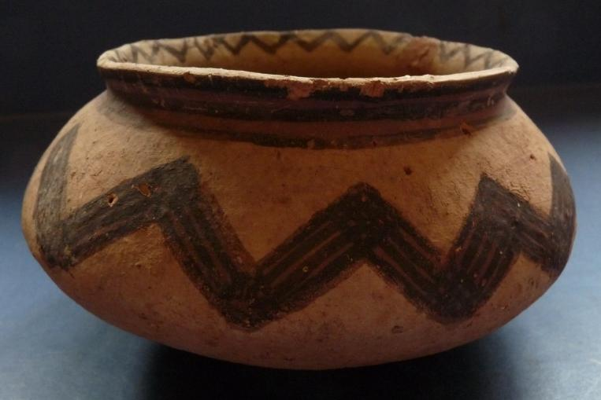

Fig. 1. Asia-China- Liaoning-Dawenkou Culture-Bowl-Zigzag-4150–3550 BCE

**Case no**.: 5

**Accession Number:**

**Formal Label:** Asia-China- Liaoning-Dawenkou Cultue-Bowl-Zigzag-4150–3550 BCE

**Display Description:**

The Dawenkou Culture 大 汶 口 (4150–2650 BCE), which was initially excavated in Xinyi, Jiangsu (1951), in Tengzhou, Shandong (1952), and in the Tai’an, Liaoning Province, Dawenkou type site (1959), now has more than 600 subsidiary sites. They are divided into early (4150–3550 BCE), middle (3550–3050 BCE) and late (3050–2650 BCE) periods. The Dawenkou Culture evolved into millet agriculture and animal husbandry.

The zig-zag motif on this bowl suggests undulating water, which was essential to the millet agriculture of Tai’an, Liaoning Province.

**LC Classification:**  DS793.S4, GN776.32

**Date or Time Horizon:** early period 4150–3550 BCE

**Geographical Area:** Tai’an area, Liaoning, China.

**Map:**

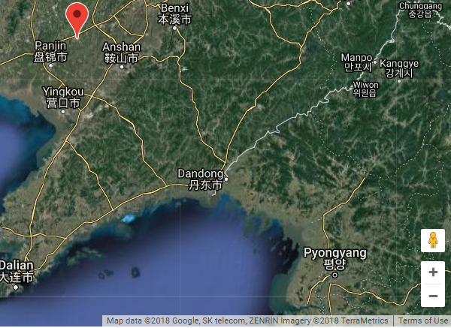

Fig. 2. Tai’an, Liaoning, China. Source: National Geospatial-Intelligence Agency, Bethesda, MD, USA

**GPS coordinates:** Liaoning, China: 41° 23' 08" N, 122° 25' 10" E

**Cultural Affiliation:** Dawenkou Culture, 大 汶口, Early Period (4150–3550 BCE)

**Media**: orange-red kaolin (generated by firing temp. and placement in kiln), manganese dioxide

**Dimensions:** Dia 6.5 in, H 3.5 in

**Weight:**

**Condition:** There is a small repair to the top rim and two, small holes to the side**.**

**Provenance:**

**Discussion:**

Dawenkou sites have tombs ranging from small to large burials, housing from 10 to 180 objects, including ceramics, lithics, jade, turtle-shells, human teeth, and pig skulls. Ceramics span the Early Period (4150–2650 BCE) and generally have a smooth often burnished finish, and are colored white, black, red, gray, brown, and yellow. Fine particle clays were selected for vessel types such as delicate ritual wares, while clays mixed with coarse–grained sand as grog were often used for heavier utilitarian wares. This particular painted Dawenkou bowl was made from a fine-medium-grained clay and was probably used for ritual purposes since painted vessels only account for about 5 % of the total ceramics for each site.

**References:**

Gao Guangren and Luan Fengshi. 2004. *Dawenkou wen hua. 大汶口文化*. Beijing: Wen wu chu ban she.



Höllmann, Thomas O. Link1983. *Neolithische Gräber der Dawenkou-Kultur in Ostchina : unter Zugrundelegung der Fundberichte*. München: C. H. Beck.

Appendix:

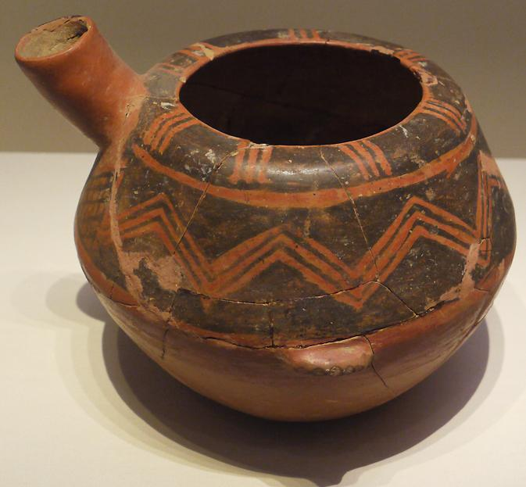

Fig. 3. Dawenkou Culture, Middle Period (3550–3050 BCE) painted and burnished He (water or wine vessel), unearthed at Dawenkou, Tai'an, Shandong Province, 1959. It is exhibited in the section of “Life and Production in Neolithic China,” an exhibition of “Ancient China” in the National Museum of China, Beijing. The Neolithic Period featured the advent of agriculture, domesticated animals, polished stone tools, and the invention of pottery. People began living in settlements with blood relatives and the economy was gradually transformed into a production-based one. (Source: China.org.cn)